Design Document

Document Author: Karyna Mangusheva
Course Name: 30 Common Phrasal Verbs in English

Executive Summary:
This design document covers the first module of the “30 Common Phrasal Verbs in English” course. Phrasal verbs are an important part of learning English – they are used very often, but they are difficult to remember and use for lower-level learners. This course is aimed towards young English Language Learners aged 18-25, who are at an A2-B1 level. The target vocabulary for this module includes the following 10 phrasal verbs: clean [x] up, end up, get away with, give up, meet up, pay for, put up with, show up, take off, think over. Learners are introduced to the different forms of phrasal verbs, including: transitive/intransitive and separable/inseparable. The course contains multimedia including: videos, screencasts, audio clips, podcasts, infographics, illustrations, and texts. Learners are assessed throughout the course though interactive games, discussions and assignments. By the end of this module, the learners will be able to confidently use 10 phrasal verbs when speaking, writing, reading and listening.

Type of Course:
This course is an informational course for English Language Learners.

What is the purpose of the course?
The purpose of the course is to build the students’ knowledge of English with phrasal verbs.

Target Audience and Learner Profile
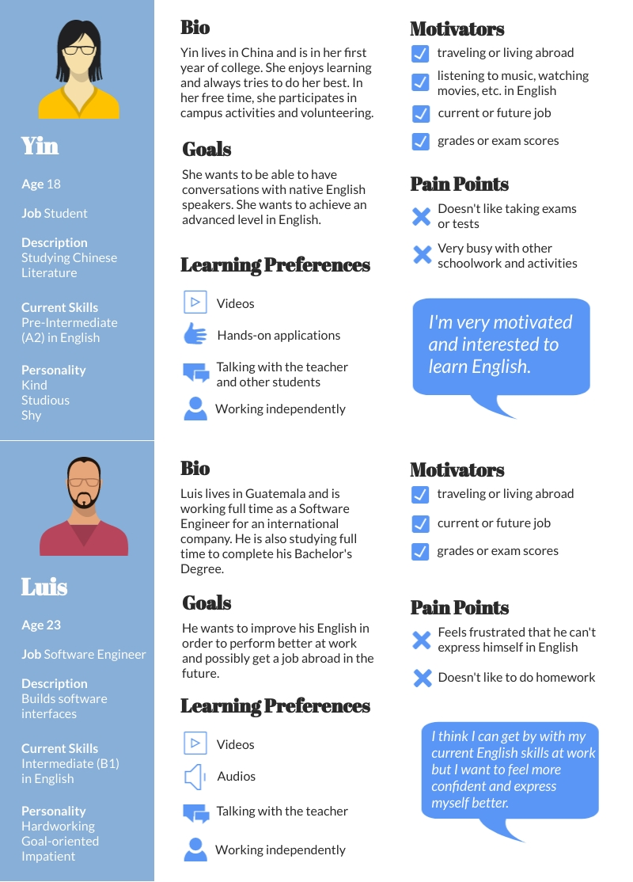
The audience consists of adult English language learners, who are at a high A2 or B1 level. They may vary from university students to working professionals and come from different countries.

Learning Gap
English uses phrasal verbs very often, but they are difficult for learners because their meanings are idiomatic and their grammar structures can be confusing (Frankfurt International School, n.d.). They are necessary to learn in order to understand native speakers and sound more natural when speaking or writing in English.
Currently, there is not a lot of communicative or interactive content available to teach or learn phrasal verbs in English. This course would fill that need.
Online learning is convenient and accessible for the target audience, who may be limited on time or money. This course would supplement the students’ regular English courses at their university or with their tutor.

Terminal Learning Objectives
By the end of this course, the learner will be able to confidently use 30 phrasal verbs when speaking, writing, reading and listening. Specifically, they will be able to:
- Explain the meaning of phrasal verbs in short dialogues.
- Write short texts using phrasal verbs.
- Summarize the meanings of short texts that include phrasal verbs.
- Explain opinions or solutions to proposed questions orally using phrasal verbs.

Enabling Learning Objectives
Objective 1: Recall the meanings of 30 phrasal verbs (including alternate meanings).
Objective 2: Classify verbs: separable/inseparable, transitive/intransitive
Objective 3: Identify the phrasal verbs when listening to short dialogues
Objective 4: Identify the phrasal verbs in short texts.
Objective 5: Compose sentences and short essays using the phrasal verbs accurately.
Objective 6: Answer oral questions using the verbs accurately.
Objective 7: Roleplay in different situations using the verbs accurately.

Instructional Strategies
Objective 1: Review flashcards with the phrasal verbs.
Objective 2: Complete sentence correction exercises.
Objective 3: Listen to short dialogues and answer comprehension questions.
Objective 4: Read short texts and answer comprehension questions.
Objective 5: Use videos, pictures, or text prompts to write sentences or short essays.
Objective 6: With a classmate or teacher, ask and answer questions using the phrasal verbs.
Objective 7: With a classmate or teacher, roleplay different situations using the phrasal verbs.

Content Sources
www.videezy.com – royalty-free video
https://www.vecteezy.com/ - royalty-free vector artwork
www.unsplash.com – royalty-free images
https://www.flickr.com/ - creative commons filtered photos
www.learnersdictionary.com – for definitions and examples of phrasal verbs
https://www.collinsdictionary.com/ – for definitions and examples of phrasal verbs
https://www.macmillandictionary.com/us

Course Sequencing
Module 1: Roommates
Target phrasal verbs:
To clean [x] up  To end up  To get away with  To give up | To meet up  To pay for  To put up with  To show up | To take off  To think over

Learning Outcomes | Teaching Methods | Assessment
Recall the meanings of 10 phrasal verbs (including alternate meanings). | Self-paced: students go through the phrasal verbs with definitions, a pronunciation clip, and an example sentence.  Review flashcards with the phrasal verbs. | Play a multiple-choice gameshow-style game. Choose the correct phrasal verbs based on the context of the sentence.
Classify verbs: separable/inseparable, transitive/intransitive | Review an infographic about different qualities of phrasal verbs.  Read notes left by a roommate and decide if sentences are correct and fix incorrect sentences, applying their knowledge of separable/inseparable, transitive/intransitive verbs. | Rearrange jumbled sentences in the correct order, applying their knowledge of separable/inseparable, transitive/intransitive verbs.
Identify the phrasal verbs when listening to short dialogues | Listen to a podcast and fill in the blanks using phrasal verbs. | Listen to a voice message and identify which phrasal verbs were used from a list.
Explain the meaning of phrasal verbs in short dialogues. | Part 1: Answer listening comprehension questions (T/F), applying their knowledge of phrasal verb meanings. | Part 2: Arrange lines from the script in order and check using the audio.  Answer listening comprehension questions (T/F), applying their knowledge of phrasal verb meanings.
Identify the phrasal verbs in short texts. | Read social media posts and identify (highlight) phrasal verbs. | Rephrase sentences within short texts using phrasal verbs.
Summarize the meanings of short texts that include phrasal verbs. | Answer reading comprehension questions, applying their knowledge of phrasal verb meanings. | Choose the correct short summary of the text, applying their knowledge of phrasal verb meanings.
Compose sentences and short essays using the phrasal verbs accurately. | Use videos, pictures, or text prompts to write sentences or short essays: write a bad roommate story based on a wordless comic strip. | Use videos, pictures, or text prompts to write sentences or short essays: describe the relationship between the roommates using phrasal verbs.
Explain opinions or solutions to proposed questions orally using phrasal verbs. | Discuss which is the “worst” roommate.  Give advice to one of the bad roommate story-tellers.  Respond to discussions on VoiceThread. | Answer oral questions using the verbs accurately: 1. What qualities does a good roommate have?  2. What is something you can’t put up with in a roommate?  Record and submit responses to the teacher.
Roleplay in different situations using the verbs accurately. | With a classmate or teacher, roleplay a situation using the phrasal verbs: calling a phone number on a roommate advertisement. | With a classmate or teacher, roleplay a situation using the phrasal verbs: interviewing a potential roommate.

Module 2: Job Searching
*This module will not be part of the Capstone Project.

Module 3: Traveling
*This module will not be part of the Capstone Project.

Learning Model
For this course, I considered Rapid eLearning and ADDIE Models. Rapid eLearning is most suitable for situations where information is needed quickly and is able to be updated easily (Courtney, 2021) – however in my capstone project, there is no sense of urgency for the learner. It is more important to provide engaging content, which is currently missing for this English language learning topic. ADDIE is an easily replicated, versatile and structured model that produces high-quality courses (ADDIE Model Pros and Cons List, 2017; Pappas, 2021). For these reasons, I chose the ADDIE model for my project.

Learning Theory
In this course, I will be using a mixture of principles from the behaviorism, cognitivism and andragogy learning theories. Since the knowledge the students need to learn is objective, a behaviorist approach is more appropriate than a constructivist approach (Zhou & Brown, 2016, p. 9-11). Gamification will be used to make the course more interactive and drill important concepts like meaning of the target vocabulary (Keramida, 2021). I will use principles of cognitivism to ensure that the content is easy to digest and connect the learning to previous knowledge. This will be accomplished through techniques such as: segmenting, off-loading, and aligning (Mayer & Moreno, 2003). Multimedia (images, illustrations and videos) will be used to enhance the presentation and help with the retention of the material (Mayer, 2005, pp. 31–32). Finally, I’ll use the principles of andragogy to guide the course as it is aimed towards adult learners. Specifically, I will explain the purpose of learning phrasal verbs at the beginning of the course, make the course task-based, take into account their backgrounds and experiences and allow students to learn mostly independently with support available (Pappas, 2021).

Course Standards
This is the first module of a 3-module course. This module is a 2-week, 4-hour, synchronous online class. Each class is approximately 30 minutes and is accompanied by a homework assignment. Week 1 can be done individually, but Week 2 needs guidance from an instructor. Week 2 can be completed one-on-one or in a group class.
Course schedule:
Week 1:
Monday | Introduction to Phrasal Verbs:  - Why are they important?  - Qualities: separable/inseparable, transitive/intransitive  Formative Assessment: Sort sentences – intransitive/transitive verbs.  Introduction to our theme “Roommates” with a few conversation questions.  Listen to the podcast for the first time.  Part 1: Listen and fill in the missing phrasal verbs.  Part 2: Arrange the script of the podcast in the correct order.  Self-paced review of the 10 phrasal verbs:  To clean [x] up  To end up  To pay for  To put up with  To show up  To get along  To give up  To meet up  To take off  To think over  Listen to the podcast a second time and answer listening comprehension questions  Formative Assessments:  Play a multiple-choice gameshow-style game about phrasal verb definitions.
Tuesday | Reading practice:  Social media posts requesting a roommate  Reviews of a roommate app  Formative Assessment: Rephrase sentences within short texts using phrasal verbs.
Wednesday | Writing practice:  Write a profile for a roommate app  Select a roommate from three profiles and write a message  Formative Assessment:  Answer a potential roommate message.
Thursday | Speaking practice: discussions about roommates  Formative Assessment: Record and send answers to questions.  Roleplays: calling a phone number on a roommate advertisement.  Formative Assessment: Practice a guided role-play with a classmate or teacher.
Friday | Module 1 Summative Assessment

Week 2:
Monday
Tuesday
Wednesday
Thursday

Formative assessments and homework:
Formative assessments and homework need to be completed prior to the next class. Each part of the course builds on each other and it’s important to get feedback on the learner’s mastery of the material. Late work will be accepted until the end of the course, but the feedback will not be immediate.
If learning individually, formative assessments and homework can be submitted by email to karynamangusheva@gmail.com. If learning together with a teacher, you can send your assignments in the chat box at the beginning of class.

Summative Assessment
The summative assessment will be completed on the last day of the course. It is self-guided, but the last portion (roleplay) needs to be done with a classmate or teacher. Time slots will be arranged to make sure every student is able to complete the last portion of the assessment.

Course Requirements
Formative Assessment: Rearrange jumbled sentences in the correct order.  Go to the provided link and enter your first name. Play the game. You may play the game again to get a better score. | 5 points
Formative Assessment: Play a multiple-choice gameshow-style game.  Go to the provided link and enter your first name. Play the game. You may play the game again to get a better score. | 5 points
Formative Assessment: for homework, arrange lines from the script in order and check using the audio.  Nothing needs to be submitted for this assessment. | 5 points
Formative Assessment: Rephrase sentences within short texts using phrasal verbs.  Multiple answers are possible. Email your sentences. | 5 points
Formative Assessment: for homework, write a short story based on a new comic strip  Write at least one sentence per panel.  Stories should use the past tenses.  Use at least three phrasal verbs in your story.  Multiple answers are possible. Email your sentences. | 5 points
Formative Assessment: Record and send answers to questions.  Use VoiceThread to submit your answers. | 5 points
Formative Assessment: Practice a guided role-play with a classmate or teacher.  Review the role-play prompt and make notes before starting.  Use at least three phrasal verbs in your dialogue.  If the teacher is not present for your role-play, record your dialogue and email it. | 5 points
Summative Assessment  Covers all learning goals in this module.  Includes multiple choice, sentence correction, listening, writing, speaking and a roleplay. | 20 points
Total | 55 points

Device compatibility
To access the course, learners will use the Canvas LMS. The LMS is compatible with most browsers. Learners should log in and test the LMS before the beginning of the course.
When learning one-on-one or in a group, learners will use the Zoom platform. A headset with a microphone is highly recommended to take classes. Test your internet, microphone and speakers before the beginning of each class.

References
ADDIE Model Pros and Cons List. (2017, January 14). NYLN Youth Leader Blog. Retrieved December 16, 2021, from https://nyln.org/addie-model-pros-and-cons-list
Courtney, F. (2021, May 12). 3 Advantages And Disadvantages Of Rapid eLearning. ELearning Industry. Retrieved December 16, 2021, from https://elearningindustry.com/3-rapid-elearning-advantages-and-disadvantages
Frankfurt International School. (n.d.). Phrasal verbs. Retrieved January 2, 2022, from http://esl.fis.edu/grammar/rules/phrasal.htm
Keramida, M. (2021, May 12). Behaviorism In Instructional Design For eLearning: When And How To Use It. eLearning Industry. https://elearningindustry.com/behaviorism-in-instructional-design-for-elearning-when-and-how-to-use
Mayer, R. E. (2005). The Cambridge Handbook of Multimedia Learning (1st ed.). Cambridge University Press. https://doi.org/10.1017/CBO9780511816819
Mayer, R. E., & Moreno, R. (2003). Nine Ways to Reduce Cognitive Load in Multimedia Learning. Educational Psychologist, 38(1), 43–52. https://doi.org/10.1207/s15326985ep3801_6
Pappas, C. (2021, May 12). ADDIE Model Vs SAM Model: Which Is Best For Your Next eLearning Project. ELearning Industry. Retrieved December 16, 2021, from https://elearningindustry.com/addie-vs-sam-model-best-for-next-elearning-project
Pappas, C. (2021, May 12). The Adult Learning Theory - Andragogy - of Malcolm Knowles. ELearning Industry. https://elearningindustry.com/the-adult-learning-theory-andragogy-of-malcolm-knowles
Zhou, M. & Brown, D. (2015) Educational Learning Theories. (2nd ed.) https://oer.galileo.usg.edu/education-textbooks/1

